
Social Media Promotions for Summer Meals
Using social media to inform your community about local summer meal programs can be a great way to increase participation. Looking for some social media inspiration? This list of social media post ideas can help get you started.The graphic on the right is also available for you to include in your posts. | 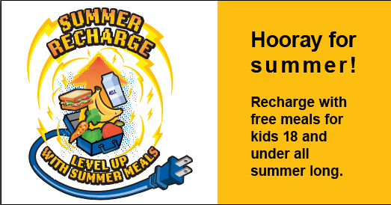

Hooray for summer! Recharge with free meals for kids 18 and under all summer long. Find your local summer meal site by texting FOOD or COMIDA to 304-304 or calling 2-1-1. For more information, visit https://www.fns.usda.gov/meals4kids #SummerMeals #SummerRechargeIA
Level up this summer! Join us for free meals for kids 18 and under at your local summer meal site. No sign up is required. Text FOOD or COMIDA to 304-304 or call 2-1-1. Visit https://www.fns.usda.gov/meals4kids. #SummerMeals #SummerRechargeIA
Did you know? Kids and teens can eat for free all summer long. Summer meal sites provide free nutritious meals for anyone 18 and under. Find your meal site by texting FOOD or COMIDA to 304-304 or calling 2-1-1. https://www.fns.usda.gov/meals4kids #SummerMeals #SummerRechargeIA
We’re cooking so you don’t have to! Kids 18 and under can enjoy free meals Monday-Friday this summer. Text FOOD or COMIDA to 304-304 or call 2-1-1. Visit https://www.fns.usda.gov/meals4kids for more information. #SummerMeals #SummerRechargeIA
What’s for lunch? Stop by and see! Free summer meals for kids 18 and under are available in (YOUR COMMUNITY NAME). Find a summer meal site by texting FOOD or COMIDA to 304-304 or calling 2-1-1. https://www.fns.usda.gov/meals4kids #SummerMeals #SummerRechargeIA
Need a last-minute lunch? Grab the kids and get to a summer meal site. When more families participate, it keeps the program strong for all of us. Text FOOD or COMIDA to 304-304 to find a site or call 2-1-1. https://www.fns.usda.gov/meals4kids #SummerMeals #SummerRechargeIA

